Tracy L Baker

CIS133

Final Project Website
Design Document

Contents
Executive Summary: 3
Statement of Purpose: 3
Content Outline: 4
Experiential Flowchart: 5
Interface Mockups: 6
Media: 7
Assets used with this Final Project website 7

Executive Summary:
The primary purpose of this website is to satisfy the requirements of my final project for my CIS133 class at Estrella Mountain Community College.
The secondary objective, one just as important to me, is having a web site that reviews all of the topics that we covered in class concerning web design. This site will serve a place where I can refer to specific pieces of HTML, CSS, and JavaScript coding, as well as site development techniques, in the future.

Statement of Purpose:
To expand on the Executive Summary, the further purpose of the site will be to serve as an archive of the work I completed. I will keep and maintain it on my personal domain’s web space once class is completed.
Although this my final project for school, it is very important to me that I keep my work. I put quite a lot of time and effort in making my vision come to fruition through writing code, research, experimentation, and testing. I will not relegate this project to the “ash heap of history” when the class is completed.
Another aspect of this section is to, “Articulate the standards by which the success of the project may be measured.” Those standards, given to use by our instructor, are:
- The entry page must be named index.html.
- It should link to at least four additional pages.
- Include title elements on each page.
- Apply style elements appropriately.
- Demonstrate concepts covered in the first five HTML Labs (links, images, lists, tables, css).
- Additional points will be earned for more advanced features.

Content Outline:
- Home Page
  - (SAME FOR ALL PAGES)
    - Project title (flash)
    - menu bar
  - Introduction
  - In-Site outline
  - (SAME FOR ALL PAGES)
    - NAUTILUS information
    - Footer
      - “Top of Page” link
      - Page HTML source link
      - JavaScript source link
      - CSS source link
      - Copyright
      - Disclaimer
- Basic Web Page
  - Explain the use of various basic tags: <html>, <head>, <body>, etc.
  - Link to W3Schools where necessary
  - Link to original assignment (in footer)
- Images & Lists
  - (Although lists were part of this assignment, refer to II.)
  - Explain the use of the <img> tag
  - Link to W3Schools where necessary
  - Link to original assignment (in footer)
- Tables
  - Explain how to use tables: <table>, <tr>, and <td>
  - Link to W3Schools where necessary
  - Link to original assignment (in footer)
- CSS Intro
  - Introduction and explanation of CSS
  - Inline styles
  - Internal and external style sheets
  - Link to W3Schools where necessary
  - Link to original assignment (in footer)
- Web Site
  - Review of what was covered in the previous assignments
  - Links to previous sections (II., III., IV., and V.)
  - Copyright and disclaimer notices
  - Link to original assignment (in footer)
- Web Design Software
  - Explain the use of tags that control “areas” : <aside>, <article>, etc.
  - Link to W3Schools where necessary
  - Link to original assignment (in footer)
- JavaScript
  - Discuss the use of JavaScript and how it can be used with HTML
  - Link to W3Schools where necessary
  - Link to original assignment (in footer)
- Flashcards
  - More JavaScript explanation, discussion of JavaScript functions
  - Discuss the use of events
  - Link to W3Schools where necessary
  - Link to original assignment (in footer)
- Web Forms
  - Discuss using forms and the manipulation of form data
  - Link to W3Schools where necessary
  - Link to original assignment (in footer)

Experiential Flowchart:
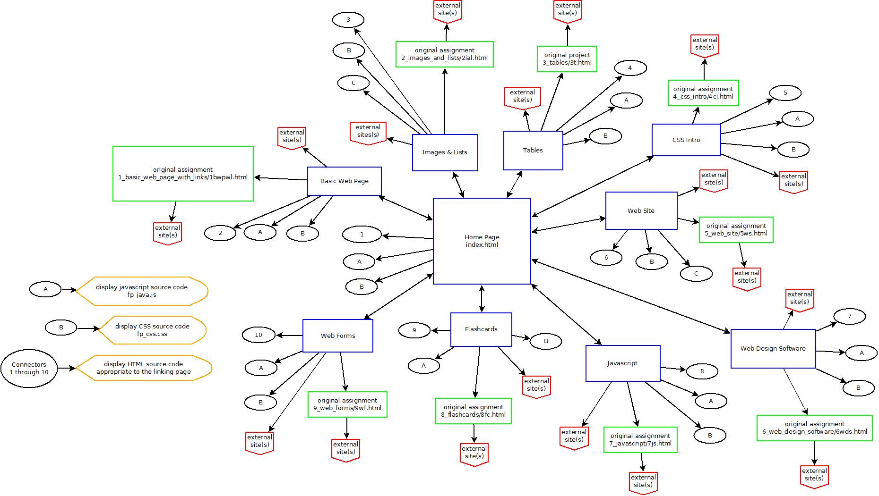

Interface Mockups:
All pages within this project’s site will follow the following mockup. Links to the original assignment pages will not be modified.

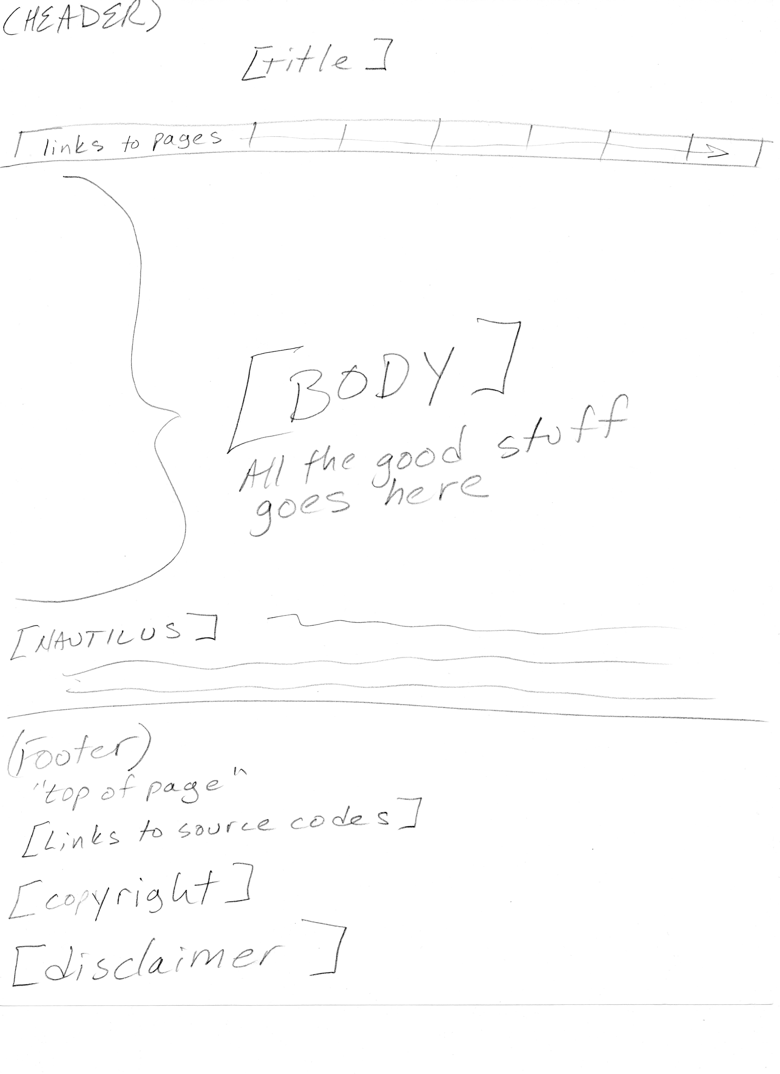

Media:

Assets used with this Final Project website
directory/filename | Description | Type
/index.html | Home Page | HTML
/bwpwl.html | Page - Basic Web Page | HTML
/ci.html | Page - CSS Into | HTML
/fc.html | Page - Flashcards | HTML
/flash.txt | Text - use with Flash | TEXT
/fp_css.css | Code - Cascading Style Sheet | CSS
/fp_flashlogo.swf | Animation - Flash | Flash
/fp_java.js | Code - JavaScript scripts | JavaScript
/ial.html | Page - Images & Lists | HTML
/j.html | Page - JavaScript | HTML
/t.html | Page - Tables | HTML
/wds.html | Page - Web Design Software | HTML
/wf.html | Page - Web Forms | HTML
/ws.html | Page - Web Site | HTML
/fp_images/shadow.gif | Image for bottom of menu | GIF
All items below this line are assets that were used with Original Assignments
/1_basic_web_page_with_links/1bwpwl.html | Basic Web Page home page | HTML
/2_images_and_lists/2ial.html | Images & Lists home page | HTML
/2_images_and_lists/BrianWilson.JPG | Photo of Brian Wilson | JPEG
/2_images_and_lists/GoodyPrints.JPG | Photo of cat prints | JPEG
/2_images_and_lists/wac.gif | whatacharacter.net logo | GIF
/3_tables/3t.html | Tables home page | HTML
/3_tables/images/1997BV.jpg | Beaulieu wine label image | JPEG
/3_tables/images/Abbey.JPG | Photo of cat - Abbey | JPEG
/3_tables/images/Dillian.JPG | Map of location of Dillian Winery | JPEG
/3_tables/images/Goody.jpg | Photo of cat - Goody | JPEG
/3_tables/images/IAFoundation.jpg | Scan of Foundation book cover | JPEG
/3_tables/images/IAFoundationEmpire.jpg | Scan of Foundation and Empire book cover | JPEG
/3_tables/images/IASecondFoundation.jpg | Scan of Second Foundation book cover | JPEG
/3_tables/images/JellyBean.JPG | Photo of cat - Jelly Bean | JPEG
/3_tables/images/LetItBe.jpg | Scan of Let It Be album cover | JPEG
/3_tables/images/Sasha.JPG | Photo of cat - Sasha | JPEG
/3_tables/images/sf.png | San Francisco Giants logo™ | PNG
/3_tables/images/SKTheStand.jpg | Scan of The Stand book cover | JPEG
/3_tables/images/WhosNext.jpg | Scan of Who's Next album cover | JPEG
/3_tables/images/yankees.jpg | Logo of the New York Yankees | JPEG

/4_css_intro/4ci.html | CSS Into home page | HTML
/4_css_intro/BrianWilson.JPG | Photo of Brian Wilson | JPEG
/4_css_intro/css.css | Code - Cascading Style Sheet | CSS
/4_css_intro/GoodyPrints.JPG | Photo of cat prints | JPEG
/4_css_intro/sf.png | San Francisco Giants logo™ | PNG
/4_css_intro/wac.gif | whatacharacter.net logo | GIF
/5_web_site/5ws.html | Web Site home page | HTML
/5_web_site/css.css | Code - Cascading Style Sheet | CSS
/5_web_site/fair_use.html | Fair Use page | HTML
/5_web_site/graphics.html | Graphics page | HTML
/5_web_site/images_and_lists.html | Images & Lists page | HTML
/5_web_site/interest.html | Interest page | HTML
/5_web_site/images/1997BV.jpg | Beaulieu wine label image | JPEG
/5_web_site/images/Abbey.JPG | Photo of cat - Abbey | JPEG
/5_web_site/images/Dillian.JPG | Map of location of Dillian Winery | JPEG
/5_web_site/images/disclaimer_copyright1024.JPG | Image used as copyright and disclaimer | JPEG
/5_web_site/images/example.gif | Photo example of GIF image | GIF
/5_web_site/images/example.jpg | Photo example of JPG image | JPEG
/5_web_site/images/example.png | Photo example of PNG image | PNG
/5_web_site/images/Goody.jpg | Photo of cat - Goody | JPEG
/5_web_site/images/GoodyPrints.JPG | Photo of cat prints | JPEG
/5_web_site/images/IAFoundation.jpg | Scan of Foundation book cover | JPEG
/5_web_site/images/IAFoundationEmpire.jpg | Scan of Foundation and Empire book cover | JPEG
/5_web_site/images/IASecondFoundation.jpg | Scan of Second Foundation book cover | JPEG
/5_web_site/images/JellyBean.JPG | Photo of cat - Jelly Bean | JPEG
/5_web_site/images/LetItBe.jpg | Scan of Let It Be album cover | JPEG
/5_web_site/images/red_arrow10.jpg | Image of a little red arrow - for list | JPEG
/5_web_site/images/Sasha.JPG | Photo of cat - Sasha | JPEG
/5_web_site/images/sf.png | San Francisco Giants logo™ | PNG
/5_web_site/images/SKTheStand.jpg | Scan of The Stand book cover | JPEG
/5_web_site/images/wac.gif | whatacharacter.net logo | GIF
/5_web_site/images/WhosNext.jpg | Scan of Who's Next album cover | JPEG
/5_web_site/images/yankees.jpg | New York Yankees logo™ | JPEG
/6_web_design_software/6wds.html | Web Design Software home page | HTML
/6_web_design_software/images/theatre_masks.gif | Theater masks image | GIF
/7_javascript/7js.html | JavaScript home page | HTML
/7_javascript/js.css | Code - Cascading Style Sheet | CSS
/7_javascript/images/j1.jpg | Image of scary cat | JPEG
/7_javascript/images/j2.jpg | Image of jack 'o lantern | JPEG
/7_javascript/images/sf.jpg | San Francisco Giants logo™ | JPEG
/8_flashcards/8fc.html | Flashcards home page | HTML
/8_flashcards/changelog.txt | Change log file | text
/8_flashcards/flashcards.css | Code - Cascading Style Sheet | CSS
/8_flashcards/flashcards.js | Code - JavaScript scripts | JavaScript
/8_flashcards/images/sf.jpg | San Francisco Giants logo™ | JPEG
/9_web_forms/9wf.html | Web Forms home page | HTML
/9_web_forms/webforms.css | Code - Cascading Style Sheet | CSS
/9_web_forms/webforms.js | Code - JavaScript scripts | JavaScript
* The San Francisco Giants logo is a trademark of the SAN FRANCISCO BASEBALL ASSOCIATES, L.P.
* The New York Yankees logo is a trademark of the NEW YORK YANKEES

